Department of Computer Science and Engineering (Data Science)
CSDS-A | Batch A2 (CSE - Data Science, Section A)
Attendance Magic: A Smart Geo-Fenced Attendance System with Live Challenge Verification
(Attendance Magic)
S.No. | Student name | Roll / hall ticket no.
1 | A.GREESHMA | 23K91A6706
2 | B.VINAY | 23K91A6740
3 | G.SRIRAM | 23K91A6757
4 | B.SAI KUMAR | 24K95A6704
Under the guidance of: [GUIDE NAME], [DESIGNATION]
CONCLUSION, FUTURE SCOPE AND REFERENCES
This document concludes the project: what was achieved, the key findings, the known limitations, concrete future work, and the numbered list of references.

1 Summary of the Work
This project set out to make classroom attendance fast and hard to fake. The result is Attendance Magic, a web application in which faculty open a time-bound, geo-fenced session and share a link or QR code, and students check in from a phone. The server runs a fixed chain of checks: eligibility (session window, roll pattern, repeat marking, device binding), a GPS geo-fence, a random live facial challenge measured on MediaPipe Face Mesh landmarks, and a face verification with InsightFace embeddings that requires both photos to show the same person, the enrolled person and nobody already recorded in the session. Every attempt is logged with its stage and reason, and faculty see live records, a map, the log, analytics and an Excel export.
No model was trained. The contribution is the verification chain, its thresholds, the application around it and the evidence: the thresholds were measured on the public LFW benchmark, the liveness check was attacked with rotated and multiple photographs, and the application was tested with 23 pytest tests and a 41-check API smoke test.

2 Objectives Achieved
All six project objectives were implemented, and a seventh (verification) was added; the objectives table at the end of Chapter 8 lists the evidence. Objective 4 (liveness) is implemented with a measured weakness that is described below.

3 Key Findings
1. On the LFW verification protocol the deployed identity threshold (0.40) accepts 98.7% of same-person pairs and none of 2,166 different-person pairs; the area under the ROC curve is 0.999 and the equal error rate 0.30%.
2. The duplicate threshold (0.45) flags 97.2% of same-person pairs as the same face, so a second identity using the same face is caught in almost all cases.
3. A single stolen photograph is rejected by seven of the eight random challenges; a photograph that already shows closed eyes passes the eye challenge 8.2% of the time.
4. The liveness check is the weakest link: a photograph rotated by 15 degrees or more passes both tilt challenges (98-99%), and an attacker with several photographs of the victim passes the full chain 49-96% of the time depending on the challenge.
5. A check-in costs about 564 ms of server time on a desktop CPU, dominated by two ArcFace embeddings (about 176 ms each).
6. The single-face rule rejected 15.7% of LFW photographs, so retakes are a real part of the user experience.
7. The haversine distance is accurate to 0.47%; the real limit of the geo-fence is GPS noise, which should be taken into account when setting the radius.
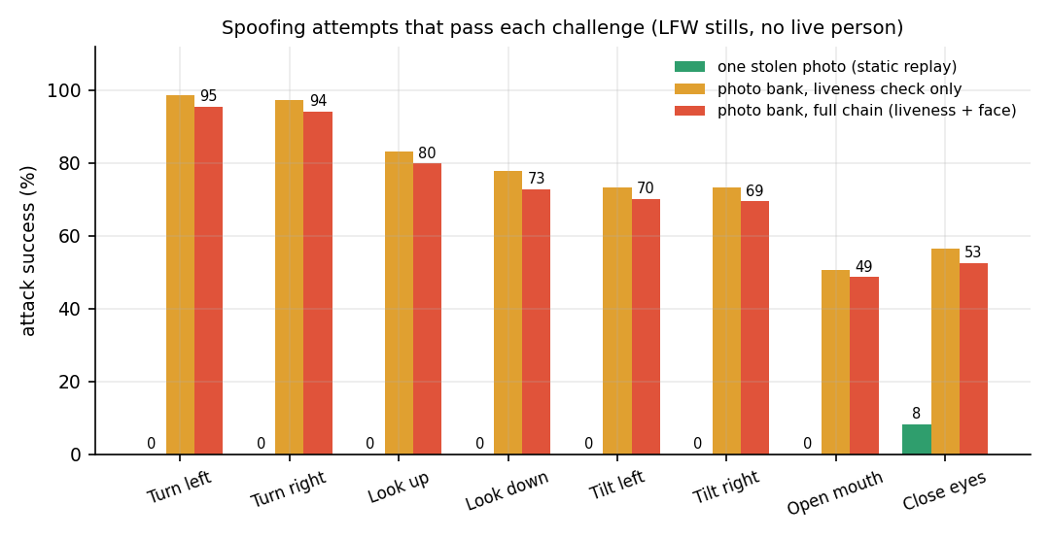
Fig. 1: Spoofing attempts that pass each challenge: a stolen photograph, and a bank of photographs

4 Practical Applications
- Lecture, laboratory and tutorial attendance in colleges, with a faculty laptop and student phones.
- Attendance at examinations or invigilated events where presence in a room matters (with a smaller radius).
- Training sessions and workshops that need a verifiable attendance record with an audit trail.
- A teaching platform for face-recognition, liveness and web-security topics, because every decision is transparent and reproducible.

5 Known Limitations
- No live-camera, phone or volunteer trial; the genuine pass rate of the challenges and the real retake rate are unknown.
- Liveness is defeated by rotated photographs and by banks of photographs; there is no texture, depth or video-based anti-spoofing.
- GPS accuracy, indoor drift and fake-location apps were not studied beyond a simulation.
- Single-process SQLite deployment with no load test; the default JWT secret and the manual-location option must be changed for real use.
- Evidence comes from public news photographs and a demo set, not from the institution's students.

6 Future Scope
The items below follow from the limitations and from the gaps found in the literature survey.

7 Improvements
- Stronger liveness. Reject a challenge frame that is only a rotation of the neutral frame (for example by checking background and perspective consistency), require several short challenges in a time-limited capture, and add a passive anti-spoofing model such as silent-face anti-spoofing [5].
- Threshold calibration on real selfies. Collect consented selfies, measure the genuine pass rate and retake rate of each challenge, and tune the neutral-frame and single-face rules accordingly.
- Better reference enrolment. Enrol from several photographs and keep the best embedding, to lower the 1.3% false-reject rate.
- Security hardening. Rate limiting and lockout on sign-in, a strong secret generated at set-up, disabling manual location in production, and a dependency audit.

8 Additional Features
- E-mail or in-app notification to students who were blocked, with the reason and a retry link.
- Attendance percentage reports per student and per course, with shortage alerts.
- Multiple faculty per course, an administrator role and department-level reports.
- Offline-tolerant check-in with a short grace window for poor connectivity.
- An export to the institution's ERP or LMS format.

9 Scalability and Deployment
- Serve over HTTPS (a reverse proxy with a certificate) so that phone cameras and GPS work without workarounds.
- Switch to PostgreSQL through DATABASE_URL and test it; run several API workers with the models loaded once per worker.
- Move the check-in wizard state from memory to a shared store so that a restart or a second worker does not lose it.
- Measure concurrent load; the duplicate scan is linear (41 ms for 5,000 faces) and the embedding takes about 0.18 s per photograph, so a GPU or a small thread pool would raise the ceiling.
- Package with containers and document backup of the database, which holds the face embeddings.

10 Further Research
- A user study on usability and acceptance, including privacy attitudes towards face capture in class.
- Evaluation of liveness on a public presentation-attack dataset so that the active challenge can be compared with passive methods [12].
- Detection of fake GPS and of screen replay (moire, specular reflection) in the challenge photographs.
- Fairness evaluation of the face-matching thresholds across skin tones, ages and lighting.
- A privacy-preserving design that never stores face embeddings centrally (on-device matching with a signed result).

REFERENCES
[1] K. B. Dharmaraj, C. N. Dhanushree, H. V. Revanth, N. Shashank and P. M. Tejaswini, "Real-Time Student Face Recognition Attendance System Using AI," International Advanced Research Journal in Science, Engineering and Technology (IARJSET), vol. 12, no. 5, pp. 1067-1072, May 2025, doi: 10.17148/IARJSET.2025.125183.
[2] "A comprehensive review on face recognition, anti-spoofing liveness verification and automated dress code enforcement techniques for smart attendance framework," International Journal of Research Publication and Reviews, 2026.
[3] A. Shandilya and H. R. Shah, "Smart attendance framework using face recognition, anti-spoofing liveness verification and automated dress code enforcement," International Journal of Innovative Science and Research Technology (IJISRT), vol. 11, no. 6, Jun. 2026, doi: 10.38124/ijisrt/26jun403.
[4] "A classroom attendance system with anti-spoofing based on ResNet101 and ArcFace for face recognition," Journal of Intelligence and Knowledge Engineering, 2026.
[5] A. E. U. Salam et al., "Automatic attendance system using silent face anti-spoofing to detect spoof on face recognition," in Proc. 2025 Int. Conf. Smart Computing, IoT and Machine Learning (SIML), 2025, doi: 10.1109/SIML65326.2025.11081084.
[6] J. Deng, J. Guo, N. Xue and S. Zafeiriou, "ArcFace: Additive angular margin loss for deep face recognition," in Proc. IEEE/CVF Conf. Computer Vision and Pattern Recognition (CVPR), 2019, pp. 4690-4699.
[7] J. Guo, J. Deng, A. Lattas and S. Zafeiriou, "Sample and computation redistribution for efficient face detection," in Proc. Int. Conf. Learning Representations (ICLR), 2022.
[8] Y. Kartynnik, A. Ablavatski, I. Grishchenko and M. Grundmann, "Real-time facial surface geometry from monocular video on mobile GPUs," in Proc. CVPR Workshops, 2019, arXiv:1907.06724.
[9] G. B. Huang, M. Ramesh, T. Berg and E. Learned-Miller, "Labeled Faces in the Wild: A database for studying face recognition in unconstrained environments," Univ. Massachusetts Amherst, Tech. Rep. 07-49, Oct. 2007.
[10] T. Soukupova and J. Cech, "Real-time eye blink detection using facial landmarks," in Proc. 21st Computer Vision Winter Workshop, 2016.
[11] G. Pan, L. Sun, Z. Wu and S. Lao, "Eyeblink-based anti-spoofing in face recognition from a generic webcamera," in Proc. IEEE Int. Conf. Computer Vision (ICCV), 2007.
[12] Z. Yu, Y. Qin, X. Li, C. Zhao, Z. Lei and G. Zhao, "Deep learning for face anti-spoofing: A survey," IEEE Trans. Pattern Analysis and Machine Intelligence, vol. 45, no. 5, pp. 5609-5631, 2023.
[13] F. Schroff, D. Kalenichenko and J. Philbin, "FaceNet: A unified embedding for face recognition and clustering," in Proc. IEEE CVPR, 2015, pp. 815-823.
[14] R. W. Sinnott, "Virtues of the haversine," Sky and Telescope, vol. 68, no. 2, p. 159, 1984.
[15] T. Vincenty, "Direct and inverse solutions of geodesics on the ellipsoid with application of nested equations," Survey Review, vol. 23, no. 176, pp. 88-93, 1975.
[16] M. Jones, J. Bradley and N. Sakimura, "JSON Web Token (JWT)," RFC 7519, Internet Engineering Task Force, May 2015.
[17] K. Moriarty, B. Kaliski and A. Rusch, "PKCS #5: Password-based cryptography specification version 2.1," RFC 8018, Internet Engineering Task Force, Jan. 2017.
[18] S. Ramirez, "FastAPI documentation." [Online]. Available: https://fastapi.tiangolo.com
[19] M. Bayer, "SQLAlchemy," in The Architecture of Open Source Applications, vol. 2, A. Brown and G. Wilson, Eds., 2012.
[20] Meta Platforms, "React documentation." [Online]. Available: https://react.dev

